**1.** The first three terms of an arithmetic sequence are 7, 9.5, 12.

(a) What is the 41st term of the sequence?

(b) What is the sum of the first 101 terms of the sequence?

(Total 4 marks)

**2.** In the arithmetic series with *n*th term *un*, it is given that *u*4 = 7 and *u*9 = 22.  
Find the minimum value of *n* so that *u*1 + *u*2 + *u*3 + ... + *un* > 10 000.

(Total 5 marks)

**3.** Consider the infinite geometric sequence 3000, – 1800, 1080, – 648, … .

(a) Find the common ratio.

(2)

(b) Find the 10th term.

(2)

(c) Find the **exact** sum of the infinite sequence.

(2)

(Total 6 marks)

**4.** The sum of an infinite geometric sequence is , and the sum of the first three terms is 13.   
Find the first term.

(Total 3 marks)

**5.** The first and fourth terms of a geometric series are 18 and  respectively.

Find

(a) the sum of the first *n* terms of the series;

(4)

(b) the sum to infinity of the series.

(2)

(Total 6 marks)

**6.** Find the coefficient of *x*3 in the binomial expansion of .

(Total 4 marks)

**7.** Find the constant term in the binomial expansion of  .

(Total 6 marks)

**8.** Find the sum of all three-digit natural numbers that are not exactly divisible by 3.

(Total 5 marks)

**9.** How many four-digit numbers are there which contain at least one digit 3?

(Total 3 marks)

**10.** A local bridge club has 17 members, 10 females and 7 males. They have to elect 3 officers: president, deputy, and treasurer. In how many ways is this possible if:

(a) there are no restrictions?

(2)

(b) the president is male?

(2)

(c) the president and deputy are the same gender?

(2)

(Total 6 marks)

**11.** Let *f* and g be two functions. Given that (*f* ◦ *g*) (*x*) =  and *g* (*x*) = 2*x* – 1, find *f* (*x* – 3).

(Total 6 marks)

**12.** The function *f* is defined by *f* : *x*  *x*3.

Find an expression for *g* (*x*) in terms of *x* in each of the following cases

1. (*f*  *g* ) (*x*) = *x* + 1;
2. (*g*  *f* ) (*x*) = *x* + 1.

(Total 6 marks)

**13.** The graph of *y* = *f* (*x*) for −2  *x*  8 is shown. On the set of axes provided, sketch the graph of *y* =  clearly showing any asymptotes and indicating the coordinates of any maximum or minimum values.

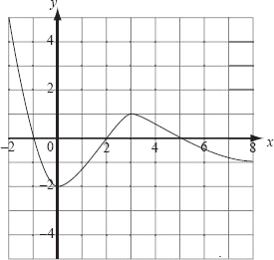 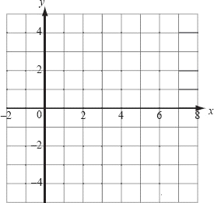

(Total 5 marks)

**14.** The functions *f* and *g* are defined below. Find the values of *x* for which ( *f* ◦ *g*) (*x*) ≤ (*g* ◦ *f* ) (*x*).

*f* (*x*) = 2*x* −1 *g* (*x*) = 

(Total 6 marks)

**15.** Let *f* (*x*) =  and *g* (*x*) = *x* − 1.

If *h* = *g* ◦ *f*, find

(a) *h* (*x*);

(2)

(b) *h*−1 (*x*), where *h*−1 is the inverse of *h*.

(4)

(Total 6 marks)

**16.** Given functions *f* (*x) =* 2*x* + 1 and *g* (*x) = x*3, find the function (*f* –l° *g*)–l.

(Total 4 marks)

**17.** The function *f* is defined for *x*  0 by *f* (*x*) = . Find an expression for *f* –1(*x*).

(Total 6 marks)

**18.** Shown below are the graphs of *y* = *f*(*x*) and *y* = *g*(*x*).

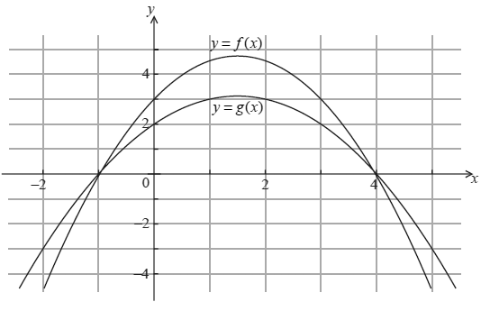If (*f*  *g*)(*x*) = 3, find all possible values of *x.*

(Total 4 marks)

**19.** Each of the diagrams below shows the graph of a function *f*. Sketch on the given axes the graph of

(a) ;



(b) .



(Total 6 marks)

**20.** The functions *f* (*x*) and *g* (*x*) are given by *f* (*x*) =  and *g* (*x*) = *x*2 + *x*. The function  
(*f* ° *g*)(*x*) is defined for , **except** for the interval ] *a*, *b* [.

(a) Calculate the value of *a* and of *b*.

(b) Find the range of *f* ° *g*.

(Total 6 marks)

**21.** A sum of $5 000 is invested at a compound interest rate of 6.3% annually.

(a) Write down an expression for the value of the investment after *n* full years.

(b) What will be the value of the investment at the end of five years?

(c) The value of the investment will exceed $10 000 after *n* full years.

(i) Write an inequality to represent this information.

(ii) Calculate the minimum value of *n*.

**(Total 6 marks)**

**22.** Solve the equation log3(*x* + 17) – 2 = log3 2*x*.

(Total 5 marks)

**23.** Given that 4 ln 2 – 3ln 4 = –ln *k*, find the value of *k*.

(Total 5 marks)

**24.** Solve the equation 22*x*+2 – 10 × 2*x* + 4 = 0, *x*  .



(Total 6 marks)

**25.** Find the **exact** value of *x* satisfying the equation

(3*x*)(42*x*+1) = 6*x*+2.

Give your answer in the form  where *a,* *b*  .

(Total 6 marks)

**26.**  Solve the equation 9 log5 *x* = 25 log*x* 5, expressing your answers in the form , where *p*, *q* .

(Total 5 marks)

**27.** Solve the following equations.

(a) ln (*x* + 2) = 3.

(b) 102*x* = 500.

(Total 5 marks)

**28.** (a) Solve the equation 2(4*x*) + 4−*x* = 3.

(5)

(b) (i) Solve the equation *ax* = e2*x*+1 where *a*  0, giving your answer for *x* in terms of *a*.

(ii) For what value of *a* does the equation have no solution?

(6)

(Total 11 marks)

**29.** Solve the equation 4*x*–1 = 2*x* + 8.

(Total 5 marks)

**30.** The solution of 22*x*+3 = 2*x*+1 + 3 can be expressed in the form *a* + log2 *b* where *a*, *b* . Find the value of *a* and of *b*.

(Total 6 marks)

**31.** (a) Find the solution of the equation, expressing your answer in terms of ln 2.

ln 24*x*–1 = ln 8*x*+5 + log2161–2*x*,

(4)

(b) Using this value of *x*, find the value of *a* for which log*ax* = 2, giving your answer to three decimal places.

(2)

(Total 6 marks)

**32.** The mass *m* kg of a radio-active substance at time *t* hours is given by *m* *=* 4e–0.2*t*. If the mass of the substance is reduced by one quarter, how long does this take (to the nearest tenth of an hour)?

(Total 4 marks)

**33.** Solve, for *x*, the equation log2 (5*x*2 – *x* – 2) = 2 + 2 log2 *x*.

(Total 5 marks)

**34.** Find the **exact** value of *x* in each of the following equations.

(a) 5*x*+1 = 625 (b) log**a** (3*x* + 5) = 2

(Total 4 marks)

**35.** Let *f* (*x*) = log*a* *x*, *x*  0.

(a) Write down the value of (b) The diagram below shows part of the graph of *f*.

1. *f* (*a*); On the same diagram, sketch the graph of .



1. *f* (1);
2. *f* (*a*4 ).

(Total 6 marks)

**36.** Solve log16 .

(Total 4 marks)

**37.** Write ln (*x*2 – 1) – 2 ln(*x* + 1) + ln(*x*2 + *x*) as a single logarithm, in its simplest form.

(Total 5 marks)

**38.** Solve the equations

  
ln *x*3 + ln *y*2 = 5.

(Total 5 marks)

**39.** Solve 2(5*x*+1) = 1 + , giving the answer in the form *a* + log5 *b*, where *a,* *b*  .

(Total 6 marks)

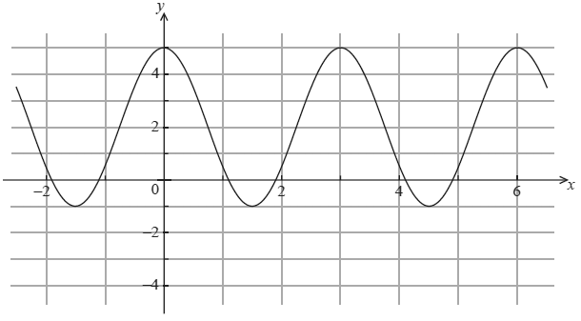**40.** The graph below shows *y* = *a* cos (*bx*) + *c*.

Find the value of *a*, the value of *b* and the value of *c.*

(Total 4 marks)

**41.** The depth, *h* (*t*) meters, of water at the entrance to a harbor at *t* hours after midnight on a particular day is given by:

*h* (*t*) = 8 + 4 sin 

(a) Find the maximum depth and the minimum depth of the water.

(3)

(b) Find the values of *t* for which *h* (*t*)  8.

(3)

(Total 6 marks)

**42.** Solve sin 2*x* = cos *x*, 0 ≤ *x* ≤ π*.*

(Total 6 marks)

**43.** The angle *θ* satisfies the equation 2 tan2 *θ* – 5 sec *θ* – 10 = 0, where *θ* is in the second quadrant. Find the value of sec *θ*.

(Total 6 marks)

**44.** Solve 2 sin *x* = tan *x*, where   *x*  

(Total 3 marks)

**45.** Given that tan 2*θ* = , find the possible values of tan *θ*.

(Total 5 marks)

**46.** The graph below represents *y* = *a* sin (*x* + *b*) + *c*, where *a*, *b*, and *c* are constants.



Find values for *a*, *b* and *c*.

(Total 6 marks)

**47.** In the diagram below, AD is perpendicular to BC.

CD = 4, BD = 2 and AD = 3.  = ** and  = **.

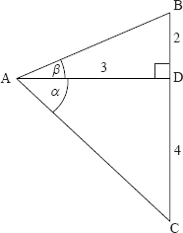

Find the exact value of cos (** − **).

(Total 6 marks)

**48.** Verify the identity .

(Total 6 marks)

**49.** In triangle ABC, AB = 9 cm, AC =12 cm, and  is twice the size of . Find the cosine of .

(Total 5 marks)

**50.** Given ΔABC, with lengths shown in the diagram below, find the length of the line segment [CD].

(***diagram not to scale)***

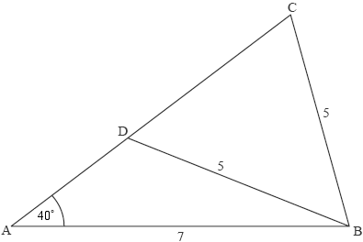

(Total 5 marks)

**51.** A fair six-sided die, with sides numbered 1, 1, 2, 3, 4, 5 is thrown. Find the mean and variance of the score.

(Total 6 marks)

**52.** The test scores of a group of students are shown on the cumulative frequency graph below.

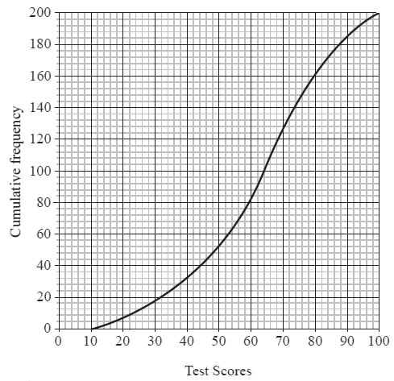

(a) Estimate the median test score.

(1)

(b) The top 10 % of students receive a grade A and the next best 20 % of students receive a grade B.

Estimate

1. the minimum score required to obtain a grade A;

(ii) the minimum score required to obtain a grade B.

(4)

(Total 5 marks)

**53.** In a sample of 50 boxes of light bulbs, the number of defective light bulbs per box is shown below.

|  |  |  |  |  |  |  |  |
| --- | --- | --- | --- | --- | --- | --- | --- |
| Number of defective light bulbs per box | 0 | 1 | 2 | 3 | 4 | 5 | 6 |
| Number of boxes | 7 | 3 | 15 | 11 | 6 | 5 | 3 |

1. Calculate the median number of defective light bulbs per box.

(b) Calculate the mean number of defective light bulbs per box.

(Total 6 marks)

**54.** In a class of 20 students, 12 study Biology, 15 study History and 2 students study neither Biology nor History.

(a) Illustrate this information on a Venn diagram.

(2)

(b) Find the probability that a randomly selected student from this class is studying both Biology and History.

(1)

1. Given that a randomly selected student studies Biology, find the probability that this student also

studies History.

(1)

(Total 4 marks)

**55.** The box-and-whisker plots shown represent the heights of female students and the heights of male students at a certain school.



1. What percentage of female students are shorter than any male students?
2. What percentage of male students are shorter than some female students?
3. From the diagram, **estimate** the mean height of the male students.

(Total 3 marks)

**56.** Robert travels to work by train every weekday from Monday to Friday. The probability that he catches the 08.00 train on Monday is 0.66. The probability that he catches the 08.00 train on any other weekday is 0.75. A weekday is chosen at random.

1. Find the probability that he catches the train on that day.
2. Given that he catches the 08.00 train on that day, find the probability that the chosen day is Monday.

(Total 6 marks)

**57.** The local Football Association consists of ten teams. Team *A* has a 40% chance of winning any game against a higher-ranked team, and a 75% chance of winning any game against a lower-ranked team. If *A* is currently in fourth position, find the probability that *A* wins its next game.

(Total 4 marks)

**58.** An influenza virus is spreading through a city. A vaccination is available to protect against the virus. If a person has had the vaccination, the probability of catching the virus is 0.1; without the vaccination, the probability is 0.3. The probability of a randomly selected person catching the virus is 0.22.

(a) Find the percentage of the population that has been vaccinated.

(3)

(b) A randomly chosen person catches the virus. Find the probability that this person has been vaccinated.

(2)

(Total 5 marks)

**59.** Use mathematical induction to prove that  for *n*  +.

**60.** Use mathematical induction to prove that  for *n*  +.

**61.** Use mathematical induction to prove 

**62.** Use mathematical induction to prove that 4*2n* – 1 is divisible by 5, for *n*  +.

**63.** Use mathematical induction to show that  for .

**64.** The complex number *z* satisfies i(*z* + 2) = 1 – 2*z*, where .Write *z* in the form *z* = *a* + *b*i, where *a* and *b* are real numbers.

(Total 3 marks)

**65.** Given that (*a + b*i)2 = 3 + 4i obtain a pair of simultaneous equations involving *a* and *b.* Hence find the two square roots of 3 + 4i.

(Total 7 marks)

**66.** Find the two square roots of . Express your answers in the form where *a*, *b*  .

(Total 6 marks)

**67.** Consider the polynomial *p*(*x*) = *x*4 + *ax*3 + *bx*2 + *cx* + *d*, where *a*, *b*, *c*, *d*  .

Given that 1 + i and 1 – 2i are zeros of *p*(*x*), find the values of *a*, *b*, *c* and *d.*

(Total 7 marks)

**68.** The polynomial *f*(*x*) = *x*2 + 9*x* + 33 has roots of *a*and *b.* Without finding the actual roots, find the exact value of the expression  using Viete’s Theorem. Leave your answer as a reduced fraction.

(Total 7 marks)

**69.** (a) Show that the complex number i is a root of the equation

*x*4 – 5*x*3 + 7*x*2 – 5*x* + 6 = 0.

(2)

(b) Find the other roots of this equation.

(4)

(Total 6 marks)

**70.** Given that  = 2 – i, *z*  , find *z* in the form *a* + i*b*.

(Total 4 marks)

**71.** When *f*(*x*) = *x*4 + 3*x*3 + *px*2 – 2*x* + *q* is divided by (*x* – 2) the remainder is 15, and (*x* + 3) is a factor of *f*(*x*).

Find the values of *p* and *q.*

(Total 6 marks)

**72.** Given that (*a* + i)(2 – *b*i) = 7 – i, find the value of *a* and *b*, where *a*, *b*  .

(Total 6 marks)

**73.** (a) Evaluate (1 + i)2, where i = .

(2)

(b) Show that (1 + i)4*n* = (–4)*n*, where *n*  .

(4)

(c) Hence or otherwise, find (1 + i)32.

(2)

(Total 8 marks)

**74.** The cubic equation *f*(*x*) = 3*x*3 + *x*2 – 6*x* + 20 has roots of *x, y* and *z.* Without finding the actual roots, find the exact value of the expression  using Viete’s Theorem. Leave your answer as a reduced fraction.

(Total 6 marks)

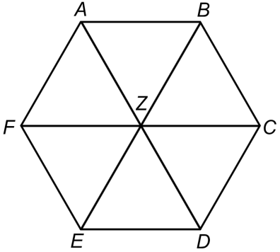**75.** Use the regular hexagon to the right to answer parts (a) and (b).

a.) List **all** equivalent vectors to .

b.) Write an equivalent vector to .

(Total 5 marks)

**76.** The three vectors ***a***, ***b*** and ***c*** are given by

 where *x*, *y*  .

(a) If ***a*** + 2***b*** – ***c*** = 0, find the value of *x* and of *y.*

(3)

(b) Find the exact value of │***a*** + 2***b***│.

(2)

(Total 5 marks)

**77.** The parallelepiped below (all 6 sides are parallelograms) has the following vertices:

, , , and .

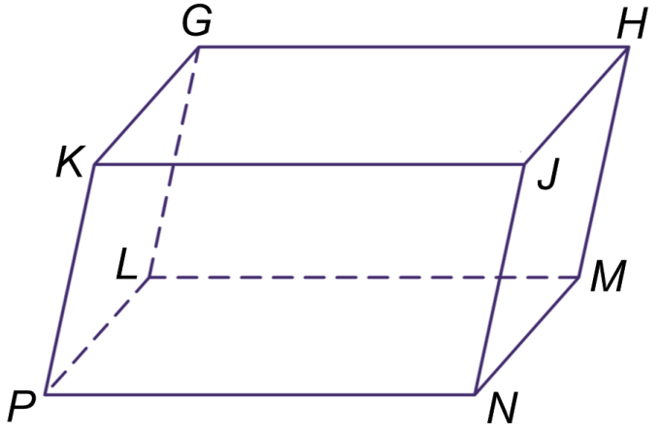

1. Find the coordinates of the remaining 4 points.
2. Find .
3. Find .

(Total 8 marks)

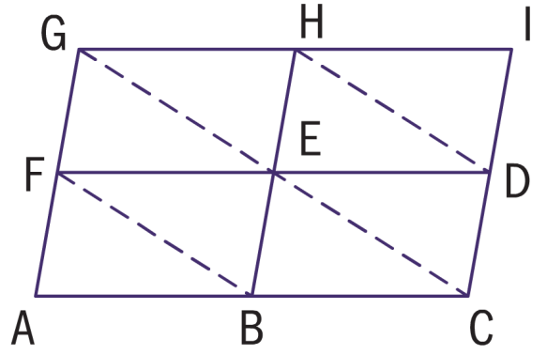**78.** The diagram below is made up of four identical parallelograms GHEF, HIDE, FEBA, and EDCB.

Let , , and .

1. Find .
2. Find the magnitude of .
3. Find the unit vectors collinear to .
4. Find a vector with the same magnitude as  in the same direction as . Write your answer in the form  where .

(Total 13 marks)

**79.** Given the points , , and , find:

(a) A vector equation of line .

(b) Parametric equations for line .

(c) Cartesian equations for line .

(d) Any 3 points **other than P, Q, and R** whichlie on line .

(e) Find the value of .

(Total 11 marks)

**80.** A triangle has its vertices at A(–1, 3, 2), B(3, 6, 1) and C(–4, 4, 3).

(a) Find .

(b) To one decimal place, find the measure of .

(c) Is  acute or obtuse? Briefly explain.

(Total 11 marks)

**81.** Parallelogram ABCD is given by the coordinates: , , and .

Let  represent the origin and  the intersection of the diagonals of ABCD.

(a) Find the coordinates of point C.

Let  represent the origin and  the intersection of the diagonals of ABCD.

(b) Find the magnitude of vector OP.

(c) Find .

(d) Are the diagonals of ABCD perpendicular to each other? Briefly explain.

(Total 7 marks)

**82.** Find the angle formed by the lines  and .

**83.** Given that ***a*** = 2 sin *θ* ***i*** + (1 – sin *θ*)***j***, find the value of the acute angle *θ*, so that ***a*** is perpendicular to the line *x* + *y* = 1.

(Total 5 marks)

**84.** Find the angle formed by the line and the plane containing the 3 points below:

  

**85.** The position vector of point A is 2***i*** + 3 ***j*** + ***k*** and the position vector of point B is 4***i*** − 5 ***j*** + 21***k***.

(a) Find the unit vector ***u*** in the direction of .

(b) Show that ***u*** is perpendicular to .

(Total 4 marks)

**86.** The line *L*1 is represented by ***r***1 =  and the line *L*2 by ***r***2 = 

The lines *L*1 and *L*2 intersect at point T. Find the coordinates of T.

(Total 6 marks)

­­­­­**87.** A ray of light coming from the point (−1, 3, 2) is travelling in the direction of vector  and meets the plane *π* : *x* + 3*y* + 2*z* − 24 = 0. Find the angle that the ray of light makes with the plane.

(Total 6 marks)

**88.** The vector equation of line *l* is given as .

Find the Cartesian equation of the plane containing the line *l* and the point A(4, –2, 5).

(Total 6 marks)

**89.** The points A, B, C have position vectors ***i*** + ***j*** + 2***k***, ***i*** + 2 ***j*** + 3***k***, 3***i*** + ***k*** respectively and lie in the plane **.

(a) Find

(i) the area of the triangle ABC;

(ii) the Cartesian equation of the plane **.

The line *L* passes through the origin and is normal to the plane **, it intersects ** at the point D.

(b) Find

1. the coordinates of the point D;
2. the distance of ** from the origin.

(Total 11 marks)

**90.** Given the complex numbers  and , find the following. Express all answers in

modulus-argument form where and . All angles must be expressed in radians.

a.)  b.)  c.) 

**91.** Given that  = 2 – i, *z*  , find *z* in the form *a* + i*b*.

(Total 4 marks)

**92.** Given that *z* = (*b* + i)2, where *b* is real and positive, find the value of *b* when arg *z* = 60°.

(Total 6 marks)

**93.** The roots of the equation *z*2 + 2*z* + 4 = 0 are denoted by *α* and *β*?

(a) Find *α* and *β* in the form *r*ei*θ.*

(6)

(b) Given that *α* lies in the second quadrant of the Argand diagram, mark *α* and *β* on an Argand diagram.

(2)

(c) Using De Moivre’s theorem find  in the form *a* *+* i*b.*

(4)

(d) Using De Moivre’s theorem or otherwise, show that *α*3 = *β*3.

(3)

(Total 15 marks)

**94.** Given that │*z*│= , solve the equation 5*z* +  = 6 – 18i, where *z\** is the conjugate of *z.*

(Total 7 marks)

**95.** (a) Express the complex number 1+ i in the form , where *a*, *b* +.

(2)

(b) Using the result from (a), show that , where *n* , has only eight distinct values.

(5)

(c) **Hence** solve the equation *z*8 −1 = 0.

(2)

(Total 9 marks)

**96.** Find the following sum, expressing your answer in modulus-argument form.



(Total 3 marks)

**97.** Consider the complex number *ω* = , where *z* = *x* + i*y*. If *ω* = i, determine *z* in the form *z* = *r* cis *θ*.

(Total 6 marks)

**98.** Consider the complex geometric series ei*θ* +  + ....

(a) Find an expression for *z*, the common ratio of this series.

(2)

(b) Show that │*z*│ < 1.

(2)

(c) Write down an expression for the sum to infinity of this series.

(2)

(Total 6 marks)

**99.** The complex number *z* is defined by

*z* = 4 

1. Express *z* in the form *re*i**, where *r* and ** have exact values.

(b) Find the cube roots of *z*, expressing in the form *re*i**, where *r* and ** have exact values.

(Total 6 marks)

**100.** Let *z*1 = *r*  and *z*2 = 1 +  i.

(a) Write *z*2 in modulus-argument form.

(b) Find the value of *r* if  = 2.

(Total 6 marks)

**101.** (a) Use de Moivre’s theorem to find the roots of the equation *z*4 = 1 – i.

(6)

(b) Draw these roots on an Argand diagram.

(2)

1. If *z*1 is the root in the first quadrant and *z*2 is the root in the second quadrant, find  in the form

*a* + i*b*.

(4)

(Total 12 marks)

**102.** Let *f* (*x*) = 6. Find *f*  (*x*).

(Total 6 marks)

**103.** Let *f* (*x*) = *x*3 – 2*x*2 – 1.

(a) Find *f* (*x*).

(b) Find the gradient of the curve of *f* (*x*) at the point (2, –1).

(Total 6 marks)

**104.** A gradient function is given by . When *x* = 0, *y* = 8. Find the value of *y* when *x* = 1.

(Total 8 marks)

**105.** Let *f*(*x*)= *kx*4. The point P(1, *k*) lies on the curve of *f*. At P, the normal to the curve is parallel to *y* =  Find the value of *k*.

(Total 6 marks)

**106.** The curve *C* has equation *y* = .

(a) Find the coordinates of the points on *C* at which  = 0.

(4)

(b) The tangent to *C* at the point P(1, 2) cuts the *x*-axis at the point T. Determine the coordinates of T.

(4)

(c) The normal to *C* at the point P cuts the *y*-axis at the point N. Find the area of triangle PTN.

(7)

(Total 15 marks)

**107.** Consider the function ƒ(*x*) = 3*x*2 – 5*x* + *k*.

1. Write down ƒ′ (*x*).

The equation of the tangent to the graph of ƒ at *x* = *p* is *y* = 7*x* – 9.

(b) Find the values of *p* and *k*.

(Total 6 marks)

**108.** Consider the curve with equation *f*(*x*) = *px*2 + *qx*, where *p* and *q* are constants. The point A(1, 3) lies on the curve. The tangent to the curve at A has gradient 8. Find the values of *p* and *q*.

(Total 7 marks)

**109.** Let *f* (*x*) = .

(a) Write down the **equation** of the vertical asymptote of *y* = *f* (*x*).

(1)

(b) Find *f* ′(*x*). Give your answer in the form  where *a* and *b*  .

(4)

(Total 5 marks)

**110.** For what values of *m* is the line *y* = *mx* + 5 a tangent to the parabola *y =* 4 – *x*2?

(Total 3 marks)

**111.** The line *y* = 16*x* – 9 is a tangent to the curve *y* = 2*x*3 + *ax*2 + *bx* – 9 at the point (1,7). Find the values of *a* and *b*.

(Total 3 marks)

**112.** Consider the function *f*(*x*) = *x*3 – 3*x*2 – 9*x* + 10, *x*  .

(a) Find the equation of the straight line passing through the maximum and minimum points of the graph *y* = *f*(*x*).

(4)

(b) Show that the point of inflexion of the graph *y* = *f*(*x*) lies on this straight line.

(2)

(Total 3 marks)

**113.** The diagram below shows a sketch of the ***gradient function f′(x)*** of the curve *f*(*x*).

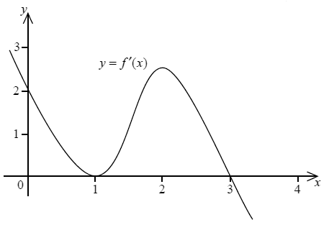

On the graph below, sketch the curve *y* = *f*(*x*) given that *f*(0) = 0. Clearly indicate on the graph any maximum, minimum or inflexion points.

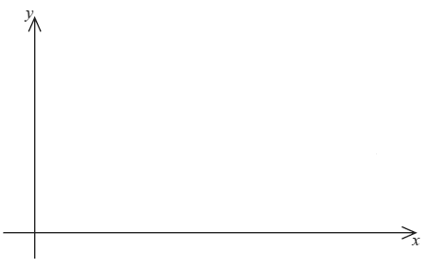

(Total 5 marks)

**114.** The function *f* is given by *f* (*x*) = , *x*  0. There is a point of inflexion on the graph of *f* at the point P. Find the coordinates of P.

(Total 6 marks)

**115.** The displacement *s* meters of a moving body B from a fixed point O at time *t* seconds is given by

*s* = 50*t* – 10*t*2 + 1000.

(a) Find the velocity of B in m s–1.

(b) Find its maximum displacement from O.

(Total 6 marks)

**116.** The quadratic function *f*(*x*) = *p* + *qx* – *x*2 has a maximum value of 5 when *x* = 3.

(a) Find the value of *p* and the value of *q.*

(4)

(b) The graph of *f*(*x*) is translated 3 units in the positive direction parallel to the *x*-axis. Determine the equation of the new graph.

(2)

(Total 6 marks)

**117.** The curve *y* = *x*2 – 5 is shown below, with point O at the origin.

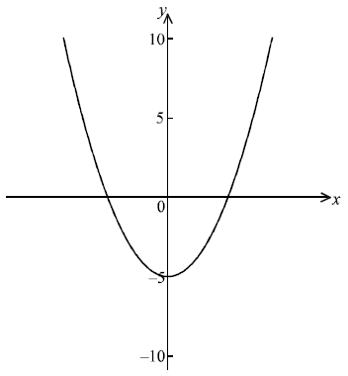

A point P on the curve has *x*-coordinate equal to *a.*

1. Show that the distance OP is .

(2)

(b) Find the values of *a* for which the curve is closest to the origin.

(5)

(Total 7 marks)

**118.** Find the equation of the normal to the curve 5*xy*2 – 2*x*2 =18 at the point (1, 2).

(Total 7 marks)

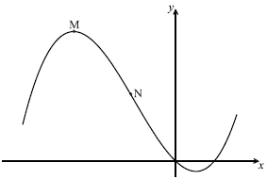**119.** Consider *f* (*x*) = *x*3 + 2*x*2 – 5*x*. Part of the graph of *f* is shown below. There is a maximum point at M, and a point of inflection at N.

(a) Find *f* ′ (*x*).

(2)

(b) Find the coordinate of M.

(3)

(c) Find the coordinate of N.

(2)

(d) The line *L* is the tangent to the curve of *f* at (3, 12). Find the equation of *L* in the form *y* = *ax* + *b*.

(3)

(Total 10 marks)

**120.** The following diagram shows a rectangular area ABCD enclosed on three sides by 60 m of fencing, and on the fourth by a wall AB.

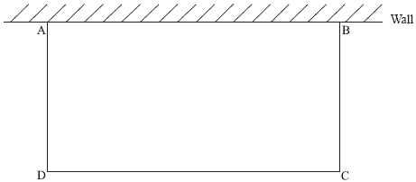

Find the dimensions of the rectangle that gives its maximum area.

(Total 6 marks)

**121.** On the axes below, sketch a curve *y* = *f* (*x*) which satisfies the following conditions.

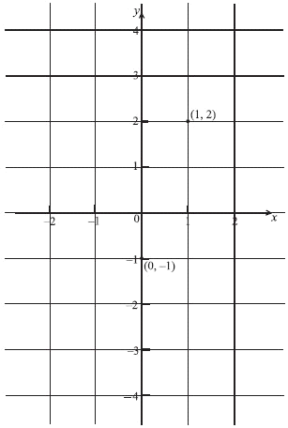

|  |  |  |  |
| --- | --- | --- | --- |
| *x* | *f* (*x*) | *f* ′ (*x*) | *f* ′′ (*x*) |
| −2  *x*  0 |  | negative | positive |
| 0 | –1 | 0 | positive |
| 0  *x* 1 |  | positive | positive |
| 1 | 2 | positive | 0 |
| 1  *x*  2 |  | positive | negative |

(Total 6 marks)

**122.** Find the equation of the normal to the curve 3*x*2*y* *+* 2*xy*2 = 2 at the point (1, –2).

(Total 7 marks)

**123.** A rocket is rising vertically at a speed of 300 m s–1 when it is 800 m directly above the launch site. Calculate the rate of change of the distance between the rocket and an observer, who is 600 m from the launch site and on the same horizontal level as the launch site.

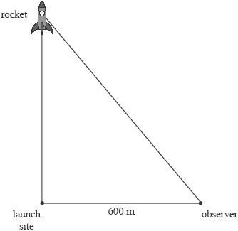

***(Diagram not drawn to scale)***

(Total 6 marks)

**124.** If *f* (*x*) = *x* – , *x*  0,

(a) find the *x*-coordinate of the point P where *f* ′ (*x*) = 0;

(2)

(b) determine and show whether P is a maximum or minimum point.

(3)

(Total 5 marks)

**125.** The curve y =  – *x*2 – 3*x* + 4 has a local maximum point at P and a local minimum point at Q. Determine the equation of the straight line passing through P and Q, in the form *ax* + *by* + *c* = 0, where *a*, *b*, *c*  .

(Total 6 marks)

**126.** Find the gradient of the curve e*xy* + ln(*y*2) + e*y* = 1 + e at the point (0, 1).

(Total 7 marks)

**127.** The function *f* is defined by *f* (*x*) = (ln (*x* *–* 2))2. Find the coordinates of the point  
of inflexion of *f.*

(Total 9 marks)

**128.** Let 

(a) Show that 

(2)

(b) Find the value of 

(5)

(Total 7 marks)

**129.** The curve *y* = e−*x* − *x* + 1 intersects the *x*-axis at P.

(a) Find the *x*-coordinate of P.

(2)

(b) Find the area of the region completely enclosed by the curve and the coordinate axes.

(3)

(Total 5 marks)

**130.** Find .

(Total 3 marks)

**131.** Over a one month period, Ava and Sven play a total of *n* games of tennis. The probability that Ava wins any game is 0.4. The result of each game played is independent of any other game played. Let *X* denote the number of games won by Ava over a one month period.

(a) Find an expression for P(*X* = 2) in terms of *n*.

(3)

(b) If the probability that Ava wins two games is 0.121 correct to three decimal places, find the value of *n*.

(3)

(Total 6 marks)

**132.** Casualties arrive at an accident unit with a mean rate of one every 10 minutes.  
Assume that the number of arrivals can be modeled by a Poisson distribution.

(a) Find the probability that there are no arrivals in a given half hour period.

(3)

(b) A nurse works for a two hour period. Find the probability that there are fewer than ten casualties during this period.

(3)

(Total 6 marks)

**133.** When a boy plays a game at a fair, the probability that he wins a prize is 0.25. He plays the game 10 times. Let *X* denote the total number of prizes that he wins. Assuming that the games are independent, find

(a) E(*X*)

(b) P(*X*  2).

(Total 6 marks)

**134.** The random variable *X* has a Poisson distribution with mean 4. Calculate

(a) P(3 ≤ *X* ≤ 5);

(2)

(b) P(*X* ≥ 3);

(2)

(c) P(3 ≤ *X* ≤ 5|*X* ≥ 3).

(2)

(Total 6 marks)

**135.** Patients arrive at random at an emergency room in a hospital at the rate of 15 per hour throughout the day. Find the probability that 6 patients will arrive at the emergency room between 08:00 and 08:15.

(Total 3 marks)

**136.** A biased coin is weighted such that the probability of obtaining a head is . The coin is tossed 6 times and *X* denotes the number of heads observed. Find the value of the ratio .

(Total 4 marks)

**137.** *X* is a binomial random variable, where the number of trials is 5 and the probability of success of each trial is *p*. Find the values of *p* if P(*X* = 4) = 0.12.

(Total 3 marks)

**138.** A coin is biased so that when it is tossed the probability of obtaining heads is . The coin is tossed 1800 times. Let *X* be the number of heads obtained. Find

(a) the mean of *X*;

(b) the standard deviation of *X*.

(Total 3 marks)

**139.** In an experiment, a trial is repeated *n* times. The trials are independent and the probability *p* of success in each trial is constant. Let *X* be the number of successes in the *n* trials. The mean of *X* is 0.4 and the standard deviation is 0.6.

(a) Find *p*.

(b) Find *n*.

(Total 6 marks)

**140.** A coin is biased so that when it is tossed the probability of obtaining heads is . The coin is tossed 30 times. Let *X* be the number of heads obtained. Find

(a) the probability of obtaining exactly 10 heads;

(b) the probability of obtaining more heads than tails.

(Total 3 marks)

**141.** Evaluate, if possible, the following limits. Use ∞ & – ∞ as necessary and show all work.

|  |  |
| --- | --- |
|  |  |
| (in terms of *x*) |  |

**142.** ***Multiple Choice. Show work for full credit.***

Which of the following is/are true about the function g if?

1. g is continuous at
2. The graph of g has a vertical asymptote at
3. The graph of g has a horizontal asymptote at
4. I only b.) II only c.) III only d.) I and II only e.) II and III only

**143.** Find the area of the region bounded by the graph of and the *x*-axis.(Synthetic division)

**144.** Find the area of the region bounded by the graph of , the *y*-axis, and the lines  and .

**145.** Find the area of the region in the first quadrant that is enclosed by , the *x*-axis, and the line .

**146.** Find the volume of the solid formed when the graph of the curve  is rotated  radians about the *x*-axis between  and .

**147.** Find the volume of the solid formed when the region between the graphs of the functions  and  is rotated through  radians about the *x*-axis between  and .