**Topic List**

|  |  |
| --- | --- |
| **Unit 01 – Series, Factorials, and Applications**   * Arithmetic Series * Geometric Series * Factorials/Permutations/Combinations * Binomial Theorem   **Unit 02 – Functions and Transformations**   * Composite and Inverse Functions * One-to-one and many-to-one * Even and Odd Functions * Transformations of Graphs   **Unit 03 – Exponents and Logarithms**   * Exponents and Factoring * Logarithm Rules and Change of Base   **Unit 04 – Trigonometry and Geometry**   * Trig Graphs (Amp, Period, Horiz/Vert Shift) * Solving Trig Equations and Unit Circle * Sector Area/Arc Length/Triangle Area * Law of Sines/Cosines   **Unit 05 – Intro Stats**   * Mean/Median/Mode/Range * Mean, Variance and Standard Deviation * Probability Tree Diagrams * Conditional Probability (Bayes’ Theorem)   **Unit 06 – Mathematical Induction**   * Mathematical Induction | **Unit 07 – Polynomials and Complex Numbers**   * Viete’s Theorem (Quadratics and Cubics) * Operations with complex numbers * Polynomial, conjugate roots, and synthetic division   **Unit 08 – Vectors, Polar, and Operations**   * Cross Products * Vector, parametric, and Cartesian forms of lines and planes * Dot Product and Angles of Lines/Planes * Euler’s Form and Polar Coordinates * Demoirve’s Theorem (Powers and Roots)   **Unit 09 – Advanced Stats**   * Binomial Distribution * Poisson Distribution * Normal Distribution * CDF vs PDF, Expected Value * Probability Density Functions   **Unit 10 – Differential Calculus**   * Derivatives * Max/Min/Points of Inflection * Related Rates and Optimization   **Unit 12 – Integral Calculus**   * Indefinite Integrals * Definite Integrals * Area Under/Between Curves * Volume of Rotations |

***Pre-Calculus***

Composite and Inverse Functions

* Composite Functions: 
* Inverse Functions:   , flip x and y, solve for y

Transformations

* Transformations of  including: 
* Combinations of more than one of the above

Trig Functions and Graphs

* 
* a = Amplitude, b = Period  , c = Phase/Horizontal Shift, d = Vertical Shift

Exponents and Logarithms

* Solving using exponents and factoring: Example Solve 2(5*x*+1) = 1 + 
* Solving using logarithms: Example log2 (5*x*2 – *x* – 2) = 2 + 2 log2 *x*
* Exponential vs Logarithmic Form: 
* Change of base: 

Solving Trig Equations

* Remember key identities/formulas
  + Trig sheet
    - Reciprocal and Pythagorean identities
    - Double angle and sum/difference formulas
* Unit Circle values = Know them well

Mean, Variance, and Standard Deviation

* Mean  = Average
* Variance =
  + Find sum of all terms squared, divide by number of terms, subtract mean squared
* Standard deviation = Square root of variance

Cumulative Frequency Diagrams and Box and Whisker Plots

* Minimum, first quartile, median, third quartile, maximum

Venn Diagrams and Conditional Probability

* Conditional Probability:  is the probability of A given B

Probability Tree Diagrams and Bayes’ Theorem

* Use trees to find individual probabilities

Mathematical Induction

* Step 1: Prove P(1) – First term true
* Step 2: Assume P(k) true – Change rule where all n become k
* Step 3: Prove P(k+1) true – Start with step 2, use Algebra to prove step 3, ending with P(k+1) being true

Complex Numbers, Operations, and Equations

* Solve for z where 
* Look for common terms to pull out such as 

Roots of Complex Numbers

* Square root of complex number: 

Conjugate Root Theorem

* If a + bi is a root of polynomial, then a – bi is also a root
* Use synthetic division

Viete’s Theorem (Including cubics)

* For quadratics  with roots  :
  + Sum of roots:  , Product of roots: 
* For cubics  with roots  :
  + Sum of roots:  , Product of roots: 
  + Also, 

2D and 3D Vectors

* Magnitude:  , where  is in component form
* Dot product:  , result is a scalar
  + Dot product can be positive (acute angle), negative (obtuse angle), or zero (perpendicular/orthogonal)
* Cross product: , result is a vector perpendicular to both u and v

Equations of Vectors, Lines, and Planes

|  |  |  |
| --- | --- | --- |
| * Vector Form of Line: * Vector Form of Plane: | * Parametric Form of Line: * Parametric Form of Plane: | * Cartesian Form of Line:      * Vector Form of Plane:   ,  normal to plane |

Angles Formed by Vectors, Lines, and Planes

|  |  |  |  |
| --- | --- | --- | --- |
| **2 Vectors** | **2 Lines** | **1 line and 1 Plane**     * n normal vector to plane | **2 Planes**     * m and n normal vectors to the planes |
| Polar Coordinates      Modulus Argument Form      Euler’s Form | | * Cartesian to Polar * Polar to Cartesian | |

DeMoivre’s Theorem and Operations with Complex Numbers



* Multiplication: 
* Reciprocal: 
* Division: 
* Powers: 
* Roots: 

***Calculus***

Slope/Gradient of a Function

Tangent/Normal to a Curve

* Tangent = Touches curve once
* Normal = Perpendicular to tangent

Max/Min of Functions

Derivative Rules

Graphs of a Function, along with First and Second Derivatives

Implicit Differentiation

Optimization, Kinematics, and Related Rates

Integration Rules

Indefinite vs. Definite Integrals

Area Under a Curve, Between Curves

Volumes of Revolution – 

***Advanced Stats***

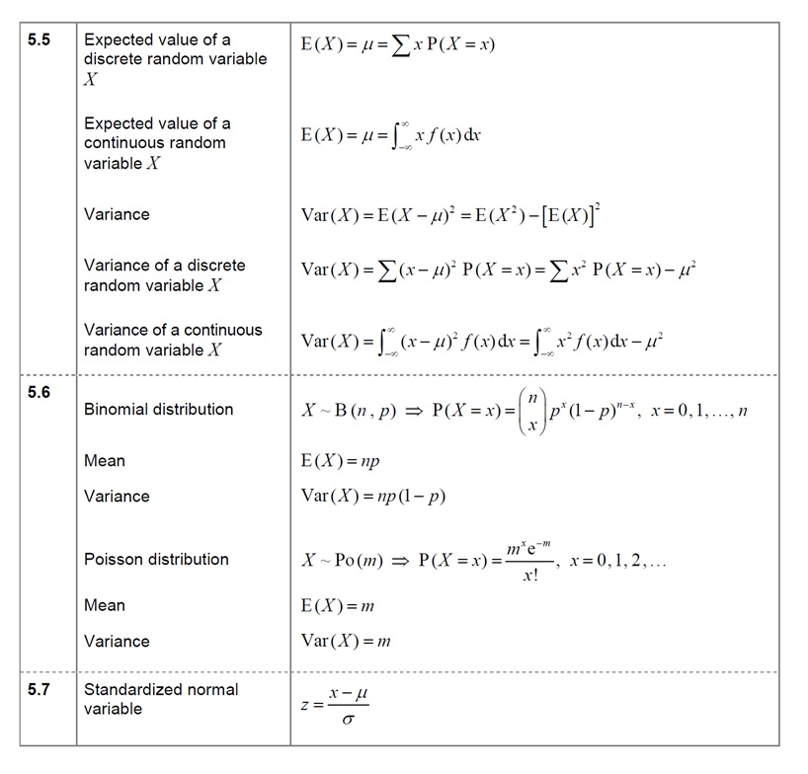

|  |  |
| --- | --- |
| **Variable or Distribution Type** | **Important Formulas** |
| **Discrete Random Variables**  probability of a specific outcome occurring  Sum of the probabilities of all possible outcomes = 1  ***Ex #1:*** A discrete random variable is given by the discrete random variable *W* where .  Find the exact value of *k, E(W)*, and *Var(W).* |  |
| **Binomial Distribution**      Fixed number of trials (*n*) with only two outcomes  Probability of success (*p*) and failure (*q*)  ***Ex #2:*** 60% of people who purchase sports cars are men. If a random number of owners is selected, let *M* be the number of male owners.   1. If 10 sports car owners are selected randomly, find *P(M>7).* 2. If 50 random cars owners are selected, what is *E(M*)? The standard deviation of *M*? |  |
| **Poisson Distribution**      ***Ex #3:*** On a particular road, serious accidents occur at a rate of 2 per week and can be modelled using Poisson distribution.   1. What is the probability that zero serious accidents occur in a given week? 2. What is the probability that at least 8 serious accidents occur in a given 4-week period? 3. Given the probability of at least one serious accident occurring in a period of *n* weeks is 0.99, find the least possible value of *n* where . |  |
| **Continuous Random Variables**    ***Ex #4:*** If *X* is a continuous random variable with PDF below:     1. Find the value of *k*. 2. Find the variance of *X*. |  |
| **Normal Distribution**    ***Ex #5:*** The test scores of a group of students are normally distributed with a mean of 62 and a variance of 144.   1. Find the percentage of students with scores above 80%. 2. What is the IQR of the scores? 3. What is the lowest score that needs to be achieved to be in the 95 percentile or higher?   ***Ex #6:*** *Let .* Find the following:      4. (Requires inverse normal) | ,    or |
| **Standard Normal Distribution**    Uses *z*-scores  Can be used when  are unknown  Can be used compare data sets with different  **Inverse Normal Distribution**  Used when area under curve is given  Often paired with Standard Normal Distribution  ***Ex #7:*** The weights adult zebras follow a normal distribution.  25% of zebras weight more than 430 kg and 15% weight less than 335 kg. Estimate the mean and standard deviation of the weights of adult zebras. |  |