**Topic List**

|  |
| --- |
| **Unit 01 – Limits, Continuity, and Differentiability**   * Algebraic Limits * Squeeze Theorem * Limits with piece-wise functions * L’Hoptial’s Rule * Continuity * Differentiability * IVT (Intermediate Value Theorem) * Rolle’s Theorem * MVT (Mean Value Theorem)     **Unit 02 – Improper Integrals**   * Fundamental Theorem of Calculus * Improper integral as limit * Comparison Tests * Upper and Lower Reimann Sums   **Unit 03 – Infinite Series and Convergence**   * Infinite Series in Summation Notation * Partial Sums * Convergence Tests * Power Series * Radius and Interval of Convergence   **Unit 04 – Taylor and Maclaurin Series**   * Maclaurin Series * Truncated Maclaurin Polynomials * Lagrange Form of Error Term * Maclaurin Series of Composite Functions * Taylor Series   **Unit 05 – Differential Equations**   * Simple differential equations * Separation of variables * Homogenous differential equations * Linear differential equations * General vs. particular solution * Implicit vs. explicit form |

**Unit 01 – Limits, Continuity, and Differentiability**

* Algebraic Limits
  + Simplifying using factoring, conjugates, and other algebraic techniques
  + Long form of derivative: 
* Squeeze Theorem
  +  , If and  approach the same limit, then approaches same limit
* Limits with piece-wise functions
  + Have to approach the same y-value at the interval changes
  + Limit exists only if LHL = RHL (Left-hand limit = right-hand limit,  )
* L’Hoptial’s Rule
  +  must be in the form  or 
  + 
  + May be repeated more than once, but must be  or  at each step
* Continuity at a point
  + Function at x=c () must exist
  + Limit must exist ()
  + Function value and limit from above steps must be same value
* Differentiability at a point
  + Must be continuous
  + Must not have any vertical tangents (  at x=c must be defined)
  + No “sharp turns” – Check derivative coming from each side at x=c to make sure they are equal
* IVT (Intermediate Value Theorem)
  + There exists 2 values such that  and  (Can be flipped as long as one >, one <)
  + Must exist a point  such that 
  + Usually used for checking existence of a root/x-intercept
* Rolle’s Theorem
  + Function must be continuous on  and differentiable on 
  + If  , then there must exist  such that 
  + Used to show that a max/min does or does not exist on an interval
  + Can prove existence or lack or multiple root of a polynomial
* MVT (Mean Value Theorem)
  + Function must be continuous on  and differentiable on 
  + There must exist a point  such that 
  + Must be some point on interval where slope of tangent is same as slope between endpoints

**Unit 02 – Improper Integrals**

* Fundamental Theorem of Calculus
  + Essentially allows for definite integration
  +  where 
* Improper integral as limit
  + 
  + Use integration techniques from Calculus 1
* Comparison Tests for Improper Integrals
  + If  for all  , then
    - If is convergent, then is convergent
    - If is divergent, then is divergent
* Upper and Lower Reimann Sums
  + Gives upper and lower boundaries on the value of infinite series that may or may not be able to be evaluated
  + 2 similar forms depending on whether the function is decreasing or increasing
  + Decreasing Function for all , then
    - 
  + Increasing Function for all , then
    - 
  + Might be able to evaluate the outer sums using infinite geometric series formulas
    -  , where  is the common ratio

**Unit 03 – Infinite Series and Convergence**

* Infinite Series in Summation Notation
  + Upper boundary becomes infinity
  + 
* Partial Sums
  + Different name for sum of the first n terms in an infinite series
  + N-th partial sum is defined as 
  + Same as  for arithmetic series
  + Same as  for geometric series
* Convergence Tests

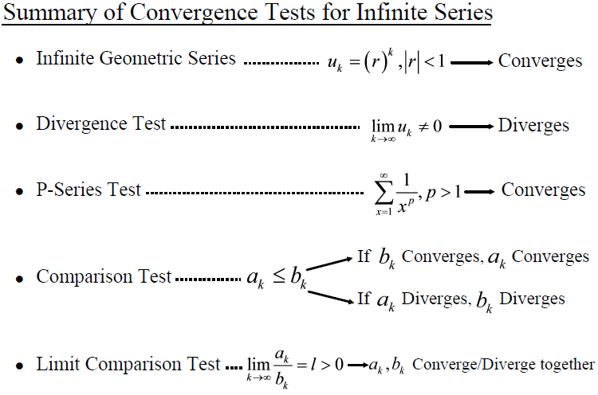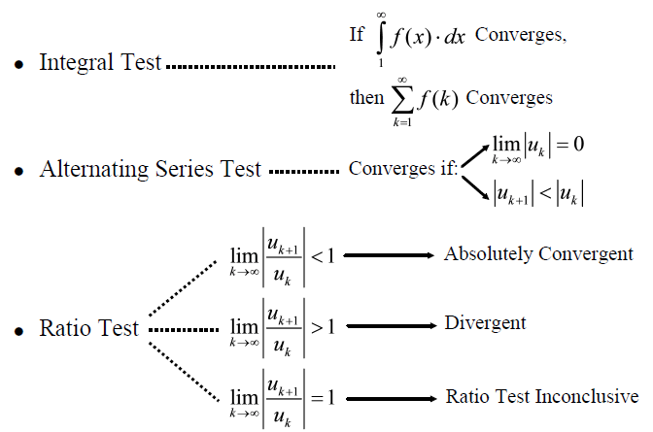

* Power Series
  + Infinite Series in the form 
  + When  , reduces to 
  + Same form we use for Maclaurin and Taylor Series expansions
* Radius and Interval of Convergence
  + ***Use ratio test***
  + If  then the series converges for all 
  + If  then the series converges for only at one specific value
  + Radius of convergence – Simple number, interval of convergence length divided by 2
  + Interval of convergence
    - Must test outer boundaries for convergence
    - Usually, one becomes the less strict alternating series test

**Unit 04 – Taylor and Maclaurin Series**

* Maclaurin Series
  + Centered around  , so every part is evaluated at 0.
  + Power series in form 
  + Can only be used if the function exists at for all derivatives of 
* Truncated Maclaurin Polynomials
  + Same as above Maclaurin expansion, but only taking the first n terms for an n-th degree Maclaurin polynomial
* Lagrange Form of Error Term
  + 
  +  is defined as the error term, or how close you are to the actual sum by only taking n terms
  + , just assume for this test that 
* Maclaurin Series of Composite Functions
  + Use the common Maclaurin shortcuts to perform expansions without doing the long, derivative method
* Taylor Series
  + Centered around  to gain a better estimate
  + Power series in form 
  + Given in formula booklet: 

**Unit 05 – Differential Equations**

* Simple differential equations
  +  , solve using simple integration techniques
* Separation of variables
  + Separate so  and  on left and  and  on right
  + Integrate per usual
* General vs. particular solution
  + General solution leaves the +C as you would for an indefinite integral
  + Particular solution will give values for x and y and solve for C
* Implicit vs Explicit Form
  + Implicit form allows you to leave as is without much simplification
  + Explicit requires you to solve for y
  + Leave in implicit form unless otherwise asked
* Note: You may mix general/particular with implicit/explicit in any way (So implicit with general is one)
* Homogenous differential equations
  + Can be written in the form
  + Once rewritten, you perform substitutions which will allow you to solve using separation of variables
  + Main substitution: 
  + Derivative of the above equation: 
  + General/particular and implicit/explicit still apply
* Linear differential equations
  + Written in the form: 
  + Use the integrating factor: 
  + Multiply through the top form by the integrating factor, then do reverse product rule