**Lesson Objectives**

After completing this review, I will be able to:

* plot points in the *x-y* coordinate plane and write equations of lines in point-slope and slope-intercept forms
* identify scatterplots as having positive, negative, or no correlation
* identify lines of fit and write equations for these lines

**Section 1 – Plotting points and writing equations.** For each of the problems below:

1. plot the two points on the coordinate plane
2. find the slope between the two points
3. write an equation of the line that passes through those two points in both ***point-slope form*** and ***slope-intercept form***.

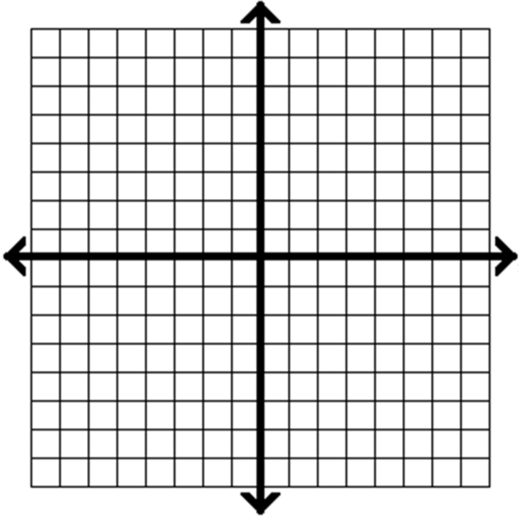1.) (2,5) and (-2,-7) 2.) (-5,5) and (0,3)



**Section 2 – Correlation.** Determine whether the following scatterplots show positive correlation, negative correlation, or no correlation between *x* and *y*.

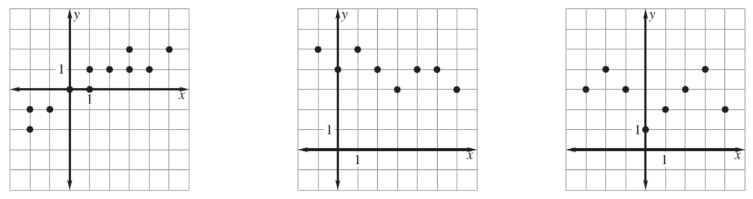

3.) 4.) 5.)

**Section 3 – Determining Lines of Best Fit.** The table below shows data of the per capita (per person) consumption of broccoli, b (in pounds) for the years 1980 through 1989. Let *t* represent the number of years since 1980. You are given a scatterplot and best-fitting line below.

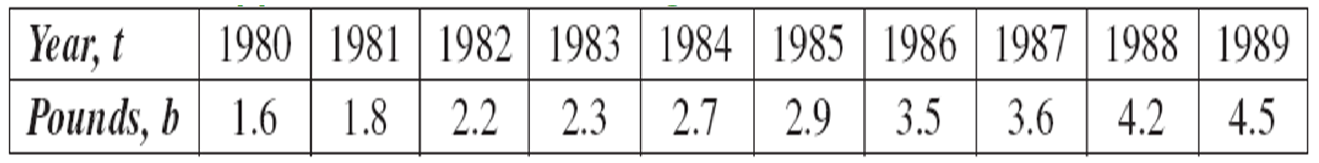

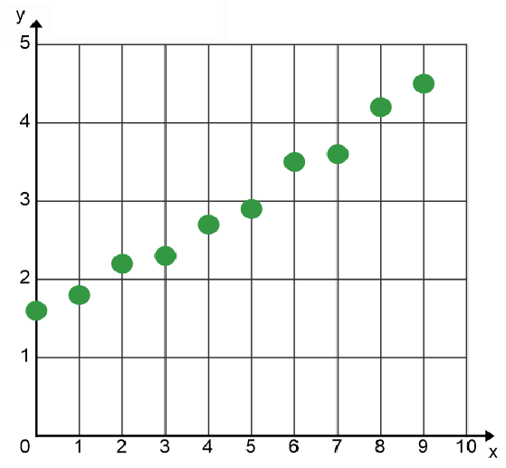6.) How many pounds of broccoli does the average consumer eat when the data begins?

7.) Does the data represent positive, negative, or no correlations?

8.) Draw a line of best fit through on the graph below.

9.) Find the slope of the line you drew in #8.

10.) Write the equation of the line you drew in #8 in both point-slope and slope-intercept forms.



11.) What would you estimate the per capita consumption of broccoli to be in 2000? Briefly explain and show any work.