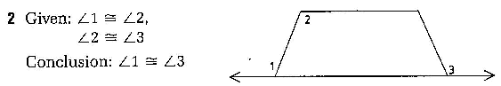
Statements Reasons

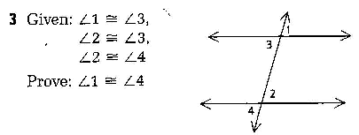
Statements Reasons

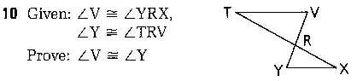
Statements Reasons

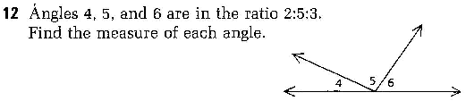
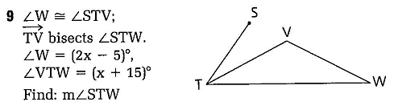

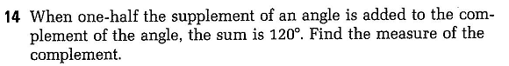

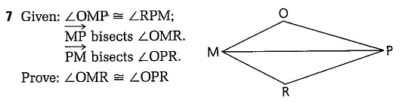
Statements Reasons

