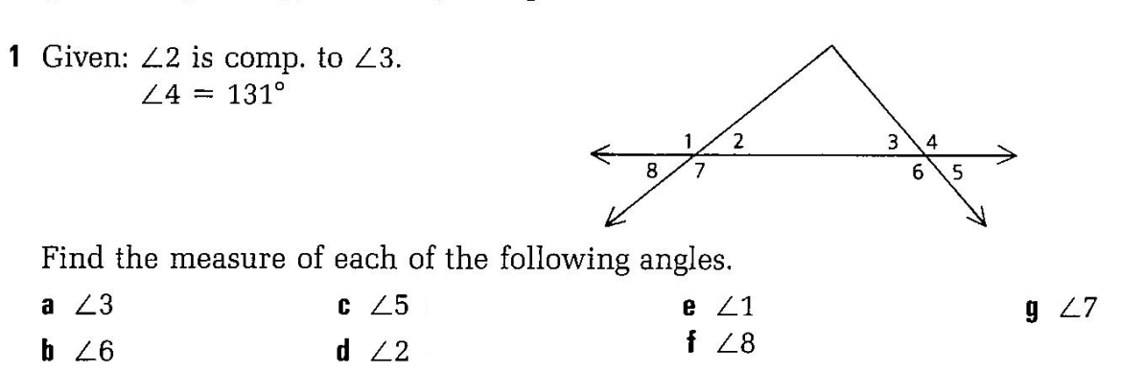

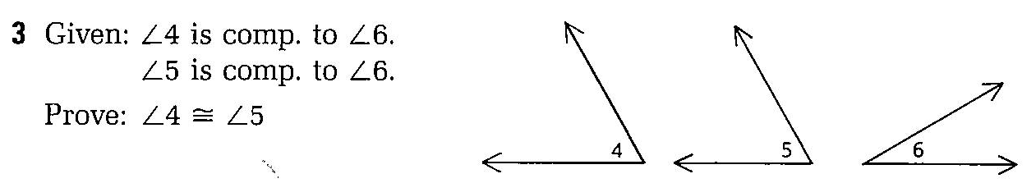
3 steps

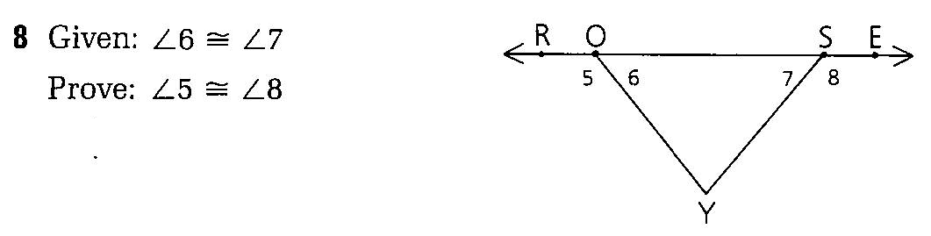
4 steps

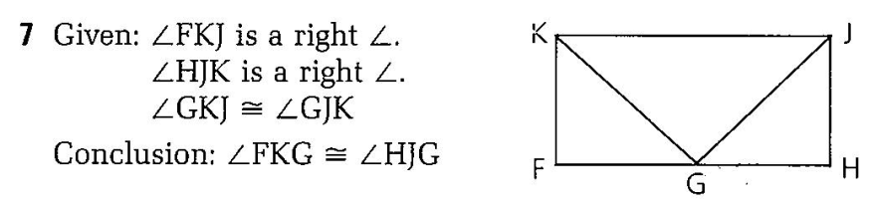

6 steps

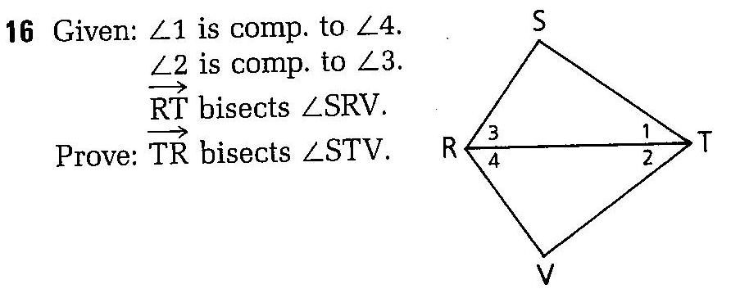
6 steps

