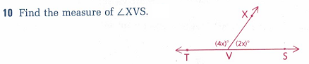

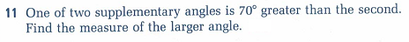

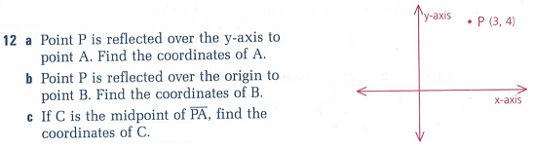

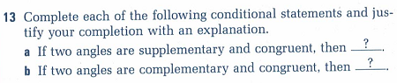

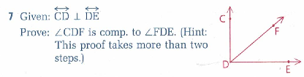

Statements Reasons

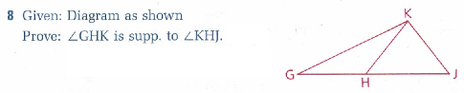

Statements Reasons

